|  |  |  |
| --- | --- | --- |
|  |  | goTAFE COMPLIANCE TEMPLATE  Review and recommendations |

Greg Bird 27.07.16

The purpose of this report is to review the current Moodle [GOTAFE Compliance Template (ID16)](GOTAFE%20Compliance%20Template%20(ID16)), and provide recommendations.

THE Student Experience 2

Navigation 2

Recommendation - Explore Tile Format as an alternative 3

Blocks 4

Recommendation – Add ‘My Courses’ block, remove TOC and others 4

Tracking, RePORTING and Auditing 5

Evidence of Participation 5

Recommendation – Create an ‘Evidence of Participation’ quiz placeholder 5

Activity Completion 6

Recommendation – Properly configure activity completion. 6

‘FOR DISCUSSION’ DESIGN FEATURES 7

Marking Guides VS Grading Forms 7

Grading scales 8

‘To be deleted…’ Tab 8

‘Teacher resources’ Tab 8

# THE Student Experience

Good Instructional Design begins with the Student Experience:

* Ensure the navigation is clear, consistent and unambiguous
* Use the simplest language possible to convey meaning
* ‘Chunk’ content into smaller sections to avoid overly long, scrolling pages
* Present this information in clear and consistent manner
* Create opportunities for student engagement
* Include ‘the teacher’s voice’ - Provide instructions to students that contextualise the learning and activities

This design should recognise that students are increasingly access Moodle from their mobile device.

## Navigation

The current “One Topic” navigation (tabs) is both functional and intuitive, and works well on a range devices and platforms.

This navigation allows for both linear and non-linear access to content. It breaks this content up into sections (tabs) to avoid long, scrolling pages.

|  |  |
| --- | --- |
|  | **../../../../../../var/folders/kb/sntb_0ns2fn0t9xbs1hn917r0000gn/T/com.skitch.skitch/DMD0359F7CD-BBFE-4B72-8AFD-A1CDDD3CD** |
| iPad Pro (12.9’) | Samsung Galaxy Tab 4 |

### ­Recommendation - Explore Tile Format as an alternative

The screen-captures below are from **Chisholm TAFE**, that widely use the **‘Tile format’** for their templates. This format is excellent as it has been optimised for the device and dynamically adapts the layout, dependent on the available screen size.

|  |  |
| --- | --- |
|  |  |
| iPad Pro (12.9’) | iPhone 6+ (portrait view) |

It also includes an ‘All sections’ button. This linearises the content and displays it all on one screen, for those students who prefer to see everything at once.

**NOTE**: There is a current open issue with eWorks for this format. Importing content from another course can remove custom tile images. This has been escalated to Androgogic

## Blocks

Blocks are an important component to overall navigation. Priority should be given to most important Student Blocks. Excessive blocks create long scrolling pages. Remove or collapse blocks that do not add value.

### Recommendation – Add ‘My Courses’ block, remove TOC and others

|  |  |
| --- | --- |
| ../../../../../../var/folders/kb/sntb_0ns2fn0t9xbs1hn917r0000gn/T/com.skitch.skitch/DMD569F3371-D247-487D-9D90-47942E069FE7/Course__GBIRD__Copy_of_-_GOTAFE_Compliance_Te | ../../../../../../var/folders/kb/sntb_0ns2fn0t9xbs1hn917r0000gn/T/com.skitch.skitch/DMD3EEA6826-6359-4820-8F65-B16658591941/Course__GBIRD__Copy_of_-_GOTAFE_Compliance_Te |
| CURRENT | RECOMMENDED |

The ‘My Courses’ block provides ready, one-click navigation into all of the users Moodle enrolments.

Consider removing the following blocks:

* Table of Contents - This simply duplicates the exact same navigation as the tabs navigation. It occupies a lot of vertical space, but does nt add value
* Copyright statement – This occupies a lot of vertical space. The same text could be built into the Moodle footer. This would prevent unnecessary scrolling

# Tracking, RePORTING and Auditing

As Moodle adoption increases and the requirements for good quality reporting data grows, establishing and promoting good practice here will become the most critical function of a template going forward.

## Evidence of Participation

Gaining valid ‘Evidence for Participation’ important trigger for funding, both early in the delivery, and throughout.

Valid evidence requires **active participation** with the course, that has been mapped to elements in the unit (or units, if in a clustered delivery). Simply reading content or clicking on links does not constitute valid participation.

Valid evidence of participation includes:

* Attempt a quiz (they do not need to ‘pass’)
* Submit an assignment (they do not need to ‘pass’)
* Post or reply to a discussion forum
* Create a blog post
* Participate in an online classroom (BBB or other)

### Recommendation – Create an ‘Evidence of Participation’ quiz placeholder

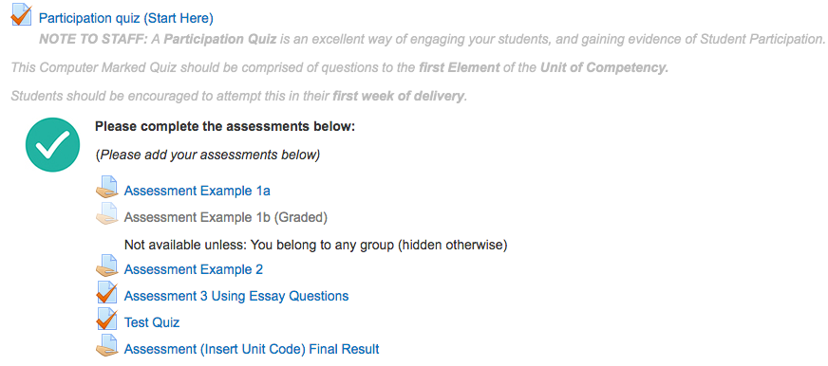Create a:  
“Participation Quiz (start here)”.

Make this prominent. Consider restricting access to other content and activities, until this quiz has been attempted.

Promote this to staff. Encourage to create a basic set of quiz questions that address Element 1 of the unit (or units).

## Activity Completion

Properly configured ‘Activity Completion’ settings are critical to accurate reporting, tracking and auditing, both within Moodle’s internal reporting, as well via Jaspersoft, for broader, aggregated reporting.

Currently, activity completion for template items is set to “**Students can manually mark the activity as completed**”. This is a poor choice:

* It does not satisfy valid evidence of participation (see above) as students can tick an activity as complete **without** actually attempting it.
* If a student properly completes an activity (e.g. they complete a quiz), the student needs to also remember to mark the activity as complete. If they fail to do so, the reporting data is corrupted.

### Recommendation – Properly configure activity completion.

Remove the “**Students can manually mark the activity as completed**” settings in favour more appropriate settings, tailored for the activity type.

|  |  |
| --- | --- |
| RECOMMENDATION FOR ASSIGNMENTS | RECOMMENDATION FOR QUIZZES |
| RECOMMENDATION FOR DISCUSSIONS |  |
|  |  |

# ‘FOR DISCUSSION’ DESIGN FEATURES

This is to address specific design features of the current template and contrast this with the practice of other Victorian TAFE Providers.

## ../../../../../../var/folders/kb/sntb_0ns2fn0t9xbs1hn917r0000gn/T/com.skitch.skitch/DMD83E15A54-861C-4965-99C7-11E9511318Marking Guides VS Grading Forms

In the current design, the use of Marking guides for assignments is promoted. Rubrics might be a better choice. I have mocked this up, and can demonstrate the advantages.

* They are very much easier and quicker to mark
* They are unambiguous; it does not require the teacher to ‘know’ what scores to enter.

We should also have a discussion on the role of the “Not Required” value, and whether this should be a feature of the marking of individual assessments.

Other TAFE’s **DO NOT** include **Not Required** in their grading. The argument is that all criteria **must** be required, or the criteria can’t be included (as stated by the Training Package).

## Grading scales

Referring to the above, a student is marked as Satisfactory or Not Satisfactoryfor **each criteria**. In addition to this, they are (automatically) marked as Satisfactory or Not Satisfactory **OVERALL.**

The use of the same terminology for **BOTH** the individual criteria **and** overall can lead to some confusion for students (*‘I can see that I’ve got lots of Satisfactory marks, why does it say that I’m Not Satisfactory?’)*

Other TAFE’s deal with this using the following, for the overall assessment:

* **Meets Requirements** (MR) – Satisfactory for all criteria
* **Further Evidence Required** (FER) – Not Satisfactory for one or more criteria.

Once a marking scale has been agreed upon, it should be added at the system level, and the current scales in the template should be deleted, to avoid future confusion.

## ‘To be deleted…’ Tab

I understand that these assignments were established to address a perceived shortcoming of the grading scales. I have a solution for this issue, and so these assignments are now likely to be redundant.

## ‘Teacher resources’ Tab

This entire tab should be hidden from students. Some of the screen video’s may need to be updated, in line with any template changes have been adopted.